THE UGANDA INTERGOVERNMENTAL FISCAL TRANSFERS (UGIFT)

REPORT ON THE FINDINGS OF HEALTHFACILITIES AND SCHOOLS IN ARUA
WESTNILE SUB -REGION

Date: 8th / 09/ 2026

ARUA CITY WESTNILE SUB-REGION
TC
- Mr. Vincent Okurut told us to go directly to the facility and we were warmly welcomed team by the Director of Aua Regional Referral Hospital and he introduced us to the senior laboratory technician for the blood bank that is MR Anguyo Gilbert
- He helped the team through out the process of carrying out the verification on the facilities.
- The Blood bank has the specific UGIFT Asset register for the UGIFT asset that were provided to the specific facilities in our Scope.

ARUA REGIONAL BLOOD BANK, ARUA CENTRAL DIVISION – ARUA CITY.

Mr Anguyo Gilbert the Senior laboratory technician said the Blood Bank has benefited in many various ways. To a larger extent the facility has benefited from the UGIFT Programme

FINDINGS
- 1 Flat self contained flat with many rooms like donor room, board room
- 1 block containing cold room storage room
- Donor couches
- Transformer
- Air conditioners
- All the required medical assets as listed in the attached facility register below and some of the photos.
- 1 Residential house for medical staff
- 1 self contain flat containing may staff rooms

CHALLENGES
- Few medical personnel
- Limited care for the blood bank
- Lack of borehole
- The cars provide are not enough when there is agent need for blood from other facilities

RECOMMENDATIONS
- Employ more medical personnel’ to take care of the facility
- Provide reliable water source
- Construct the marram road coming to the facility to reduce bring too much soil during rain season.

IMAGES FROM SOURCE
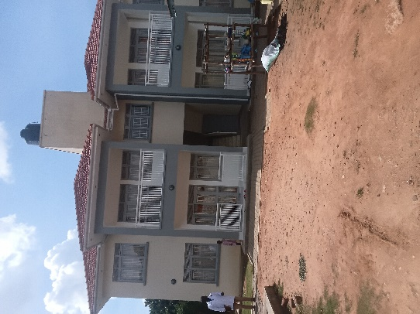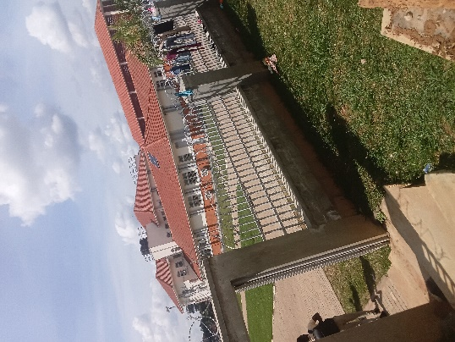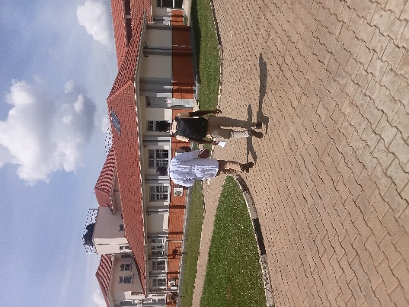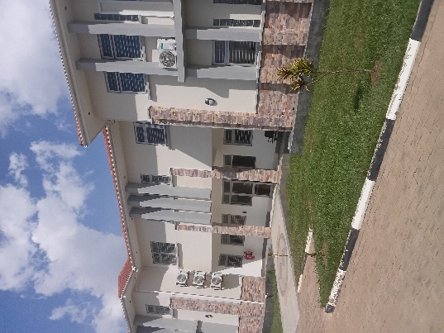
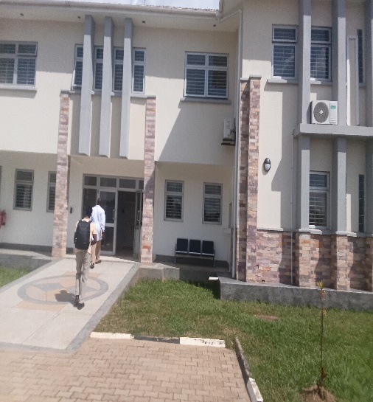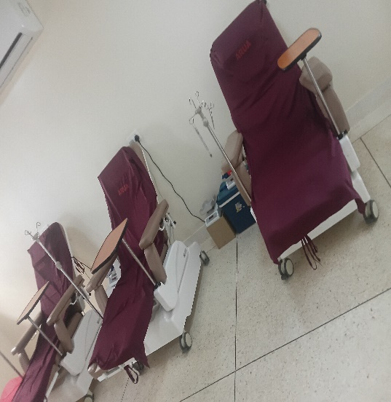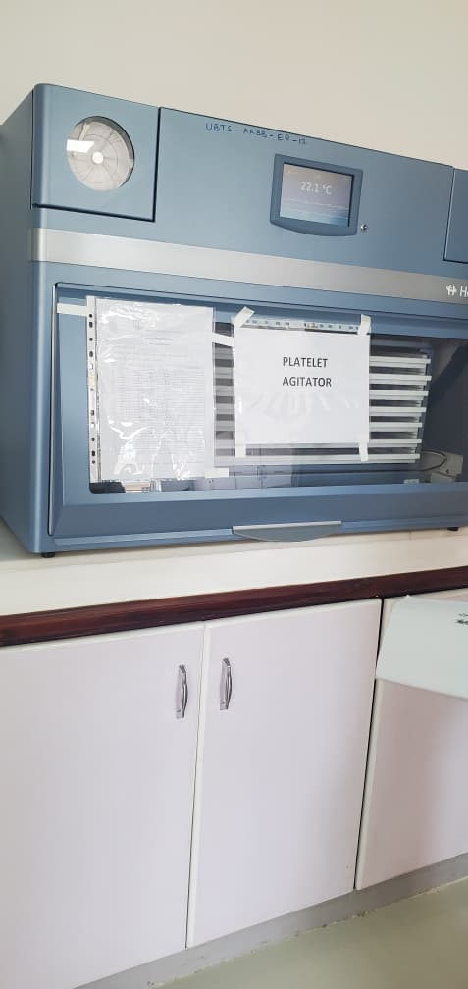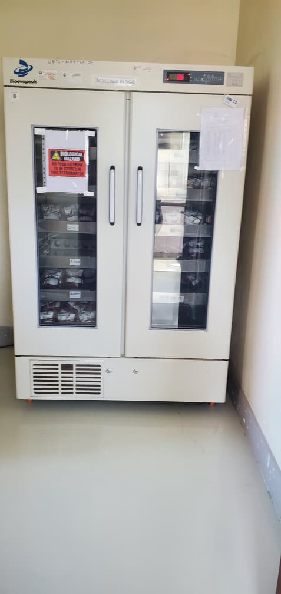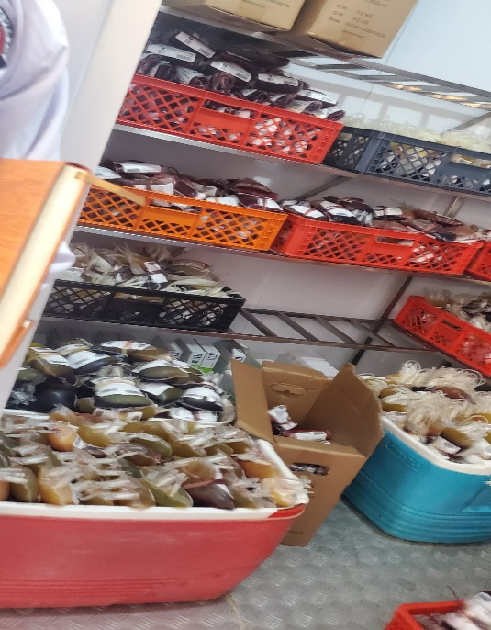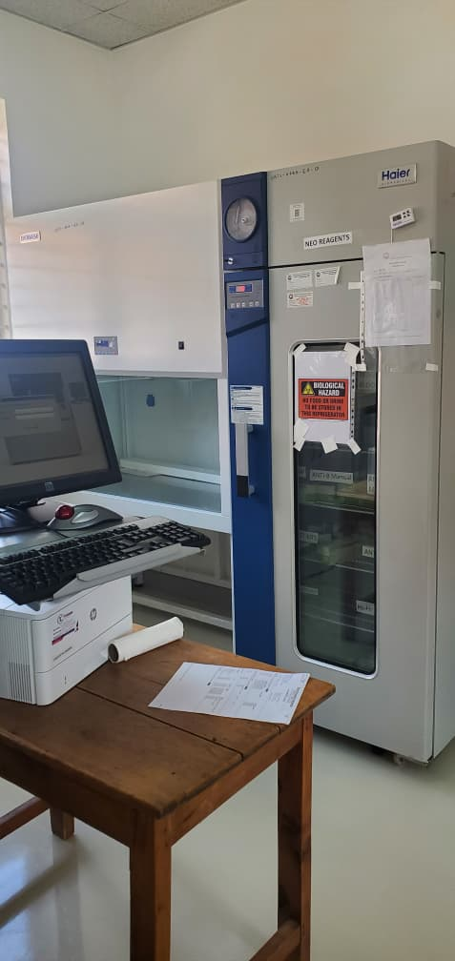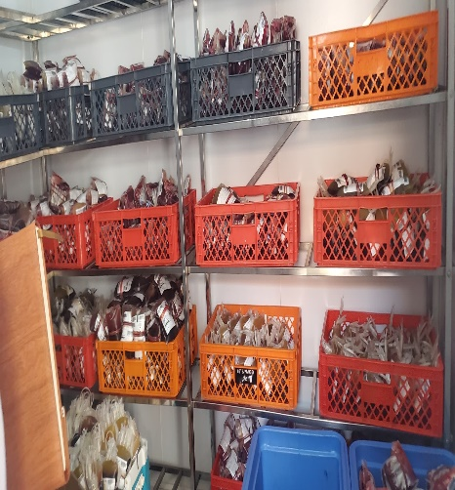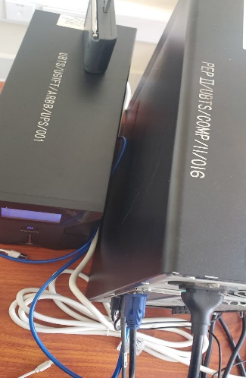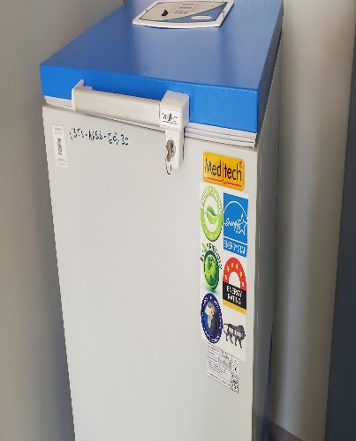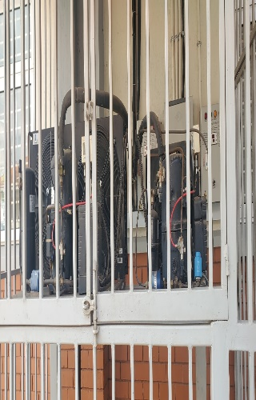

THE UGANDA INTERGOVERNMENTAL FISCAL TRANSFERS (UGIFT)

REPORT ON THE FINDINGS OF SCHOOLS IN – ARUA DISTRICT WESTNILE SUB REGION

Date: 10th / 09/ 2026
ARUA DISTRICT AROI SUB-COUNTY, WESTNILE SUB-REGION
CAO
Mr Wamburu Soita Emmanuel warmly welcomed us as a team and he introduced us to the DEO who helped us to access some of the records from accounts department. DEO also helped us to call the headteacher of the school. Then He later arranged a car for team to reach the school

ST PETERS SEED SECONDARY SCHOOL ALIBA AROI SUB COUNTY IN ARUA DISTRICT .
Information from the focal person in charge of the facility. She warmly welcomed the team and took the team through the asset and facilities, the school so far benefited from UGIFT Programme.
NB: the facility has no asset register for UGIFT assets. The work at the facility was substantially done.

FINDINGS
- 3 Blocks each with 2 class rooms
- 1 Science laboratory block with two labs i.e. Biology and Chemistry
- 1 ICT block with two labs i.e. Computer room and Library room
- 1 administration block
- 3 water tanks 1 for the school that is 5000liters and 2 for the s
- 6 Staff house units with 6 staff Kitchen units
- 2 Toilets at staff quarters each with 2 stanzas
- 1 staff school toilet with 2 stanzas
- 2 student toilets for both girls and boys each with 5 stanzas
- Not fenced
- Compound not levelled properly

FURNITURE
- 117 Desks, in all the classrooms class
- 12 staff room Tables
- 24 book shelves
- 76 Stools for laboratories
- 12 office chairs
- 303 Wooden and Metallic chairs
- 6 War drops

ICT DEPARTMENT
- 20 CPU’s
- 20 Monitors
- 20 uninterrupted power supply
- 1 Computer Server
- 1 Projector screen
- 1 Camera
- 1 printer
- 1 screen
- 1Servers
- 1 Switch
- 1 air conditioner

CHALLENGES
- Most of the book shelves and stools are incomplete
- 01 computer screen was removed by a thief
- The facility is not fenced
- Have no reliable power source/Supply
- Pathways and compound not well-grounded
- Delayment by the contractors to finish the assign work in time
- No medical facility.
- Lack of reliable source of water.

RECOMMENDATIONS
- Contractors to be given a fixed time to finish their work
- Need for power in order to connect all the ict equipment’s.
- Need for medical facility or equipment’s for the school
- Ugift program to continue in order to construct more staff rooms
- Need for more water tanks

IMAGES FROM SCHOOL

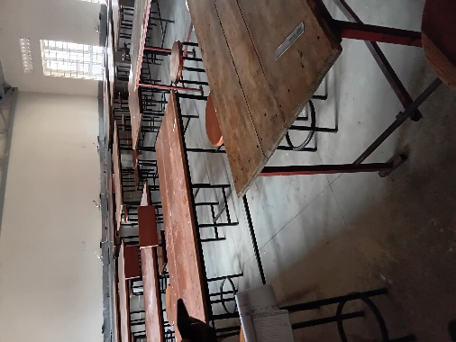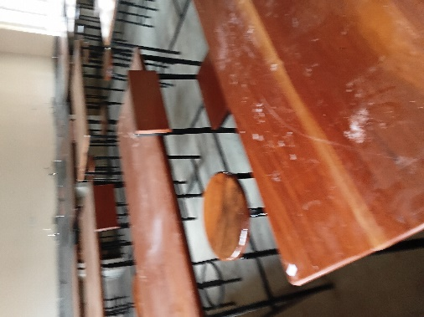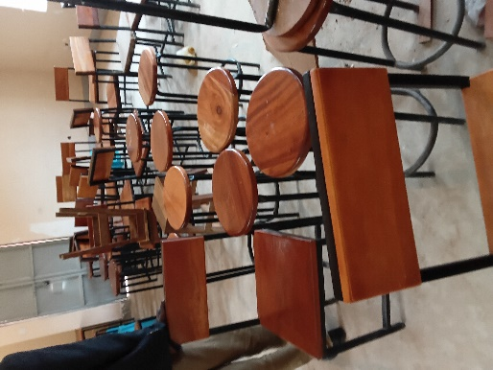
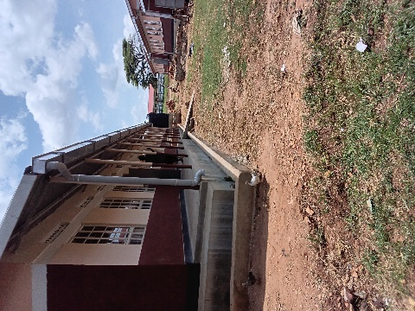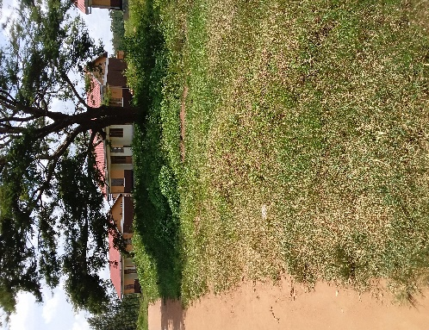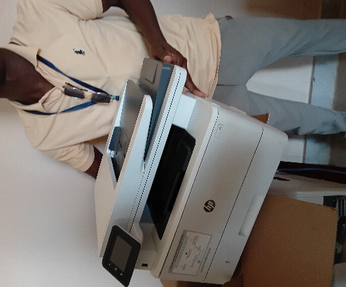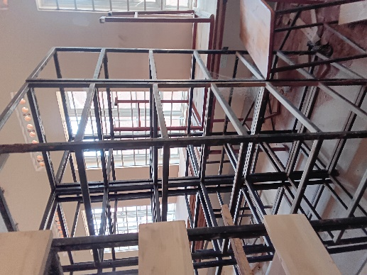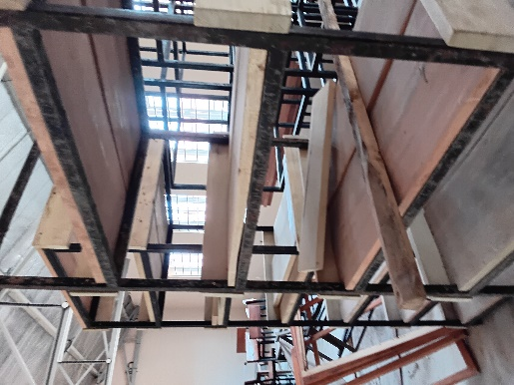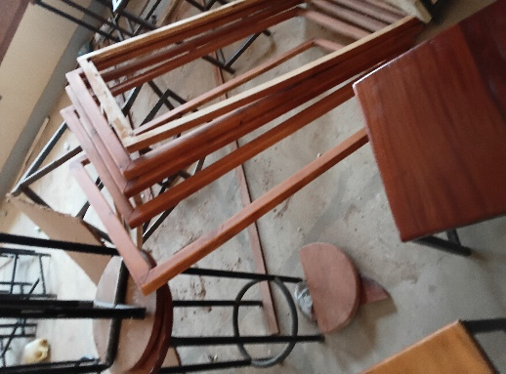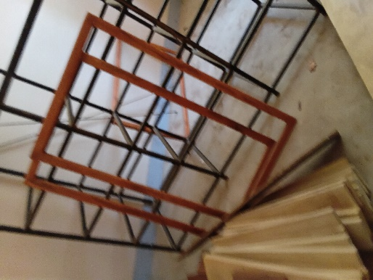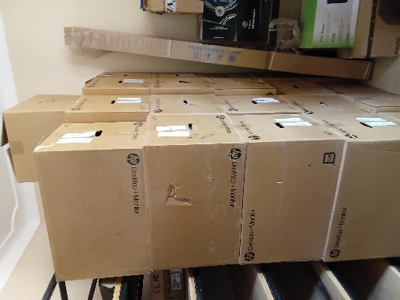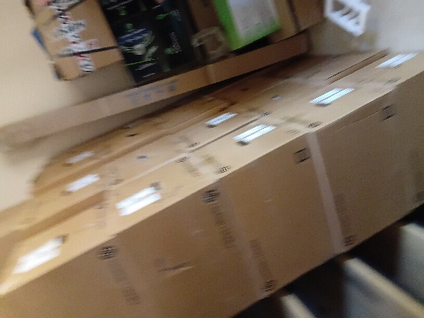s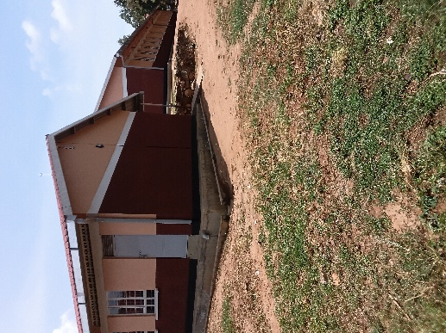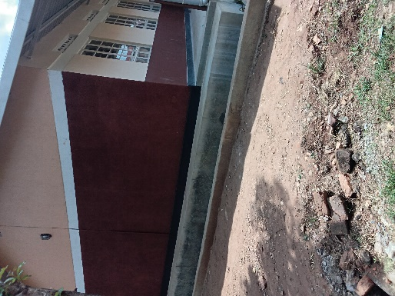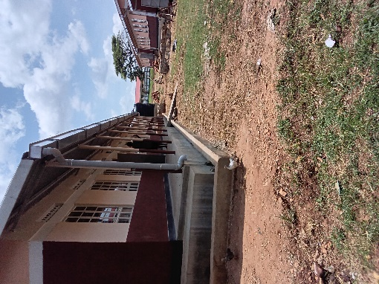

Report By: SIKIA FIKIRA
Tel: 0783517165
Email: fikirasikia@gmail.com

